Thread Model Diagram

Authentication and Authorization in Backend
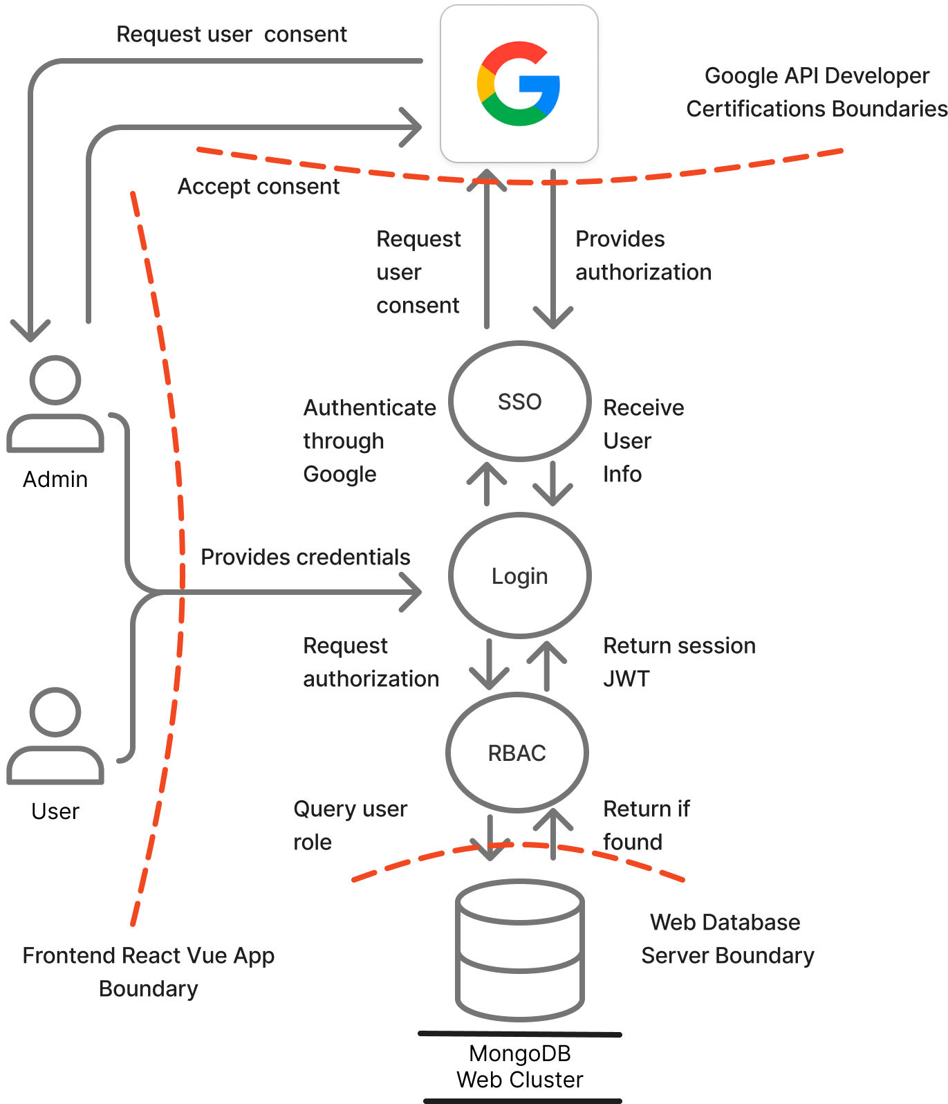

Middleware and Auth route
- Authenticate route creates the session and the token
- Authorize middleware grants user access based on the role

Dashboard in Frontend
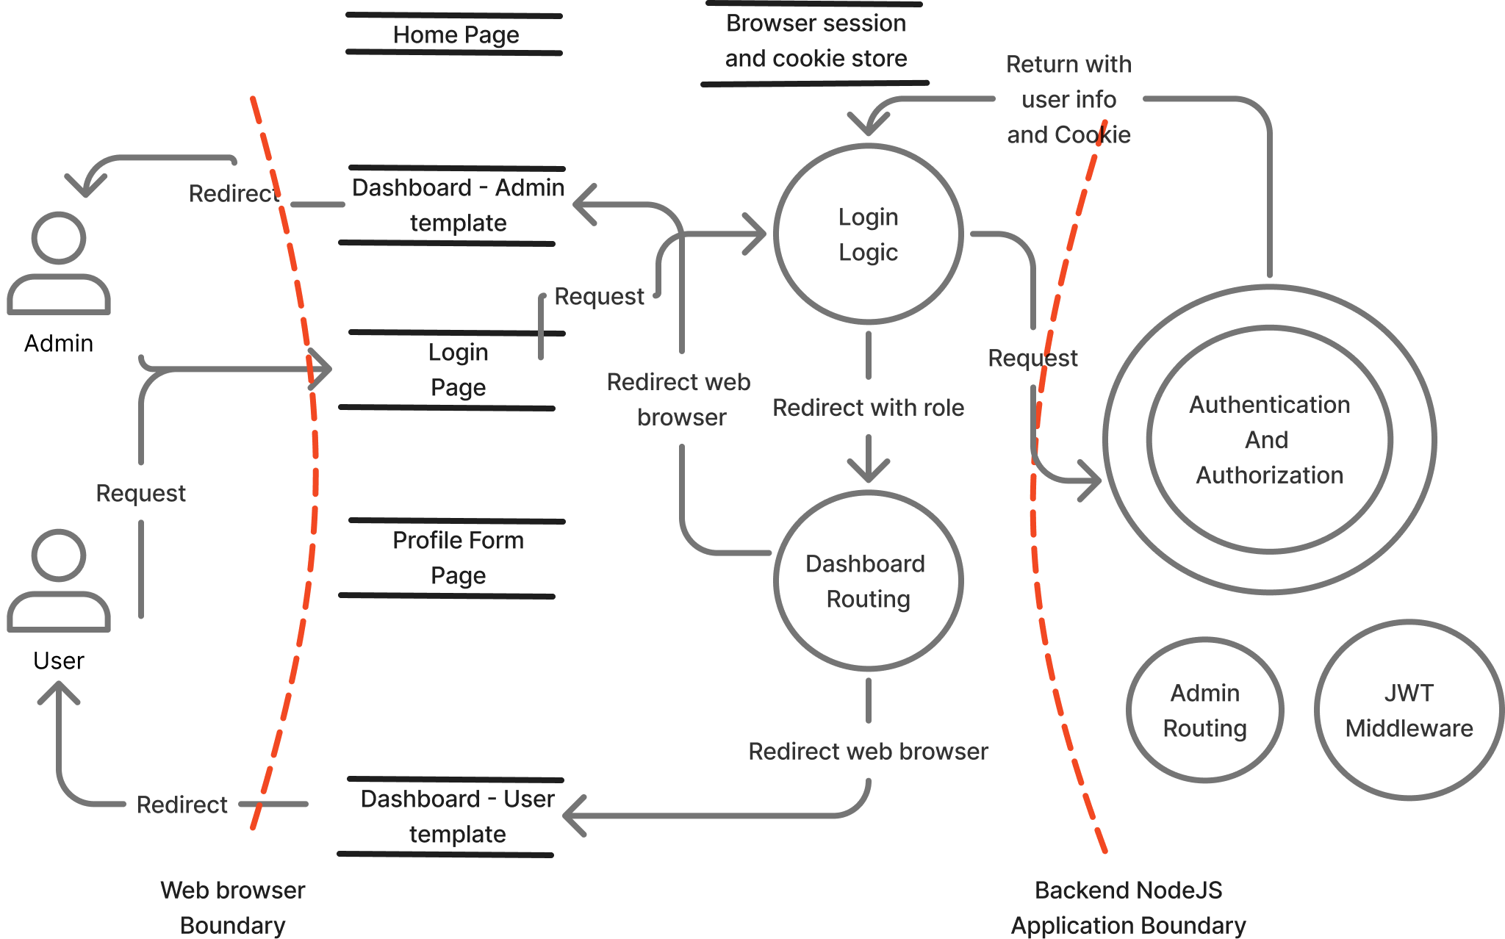

Pages stored
- Home
- Login/Register
- Dashboard – Admin
- Dashboard – Regular
- Edit Profile Form

Resources stored in browser
- Bearer token as cookie
- User session data

Critical Assets

User records in MongoDB
- Email
- hashed password
- role
- biography

Auth tokens/cookies
- Authorization token JWT
- express-session cookies

Project Configuration
- OAuth credentials in .env file
- HTTPS key/cert in cert/ files
- backend code and dependencies

frontend local storage
- Email
- Authorization info
- role
- username

Item | STRIDE | Impact | Likelihood | Mitigation
Client-controlled role during registration in Routes/auth.js lets anyone self-assign admin; no auth/ownership check on PUT /api/auth/profile allows updating any user by email. | Spoofing and elevation | high | high | Enforcing role = 'user' server-side, requiring an authenticated user from JWT/cookie and matching req.user.id/email instead of trusting body.
Admin routes rely on Authorization: Bearer in middleware/decodeJWT.js, but login sets only an auth_token cookie, so clients may skip auth entirely or fail unexpectedly; missing session validation on profile route | Spoofing | medium-high | high | Reading/verifying JWT from cookie and rejecting when missing; add auth middleware to all protected routes.
Session cookie set with secure: false, SameSite lax; HTTPS key/cert stored in repo; default secrets in settings.js; no rate limiting on auth endpoints. | Tampering | medium-high | medium-high. | Enabling secure in prod, rotating secrets from env only, removing bundled keys, and adding rate limiting + brute-force protections
No audit logging around admin actions; missing request/response trace for sensitive routes. | Repudiation | Medium | Medium | Reduce risk with structured auth logs and correlation IDs.
Registration and login return raw error messages; Google OAuth callback redirects with user display name in URL; default env fallbacks could leak predictable secrets. | Information disclosure | Medium | Medium | Use generic errors, don’t echo Personal Information in URLs, and require real env secrets.
No size limits on JSON requests; no throttling on login/register/profile. | Denial of service | medium | Medium | Reduce risk with express.json ({ limit }), helmet, and rate limiting.
Registration stores unsanitized username/bio (no validation), so reused views could store XSS; profile route sanitizes but trusts body email (possible IDOR). | XSS/Injection | Medium | Medium | Use a strict validation/encoding on all user-supplied fields and ownership checks.

